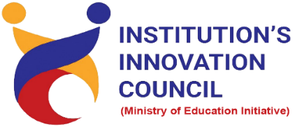

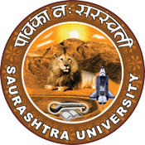

Financial planning for youngsters
21 September 2022
At
Virtually on Webex
Saurashtra University Campus, Rajkot
Contents
Saurashtra University – IIC 2
Event Schedule 2
Event Registration Link 2
Brief about Event 3
Key Points 3
Outcome 3
About the Speaker/Chief Guest 4
Connect Us: 5

Saurashtra University – IIC
The university is dedicated to instruction, research, and extending knowledge to the public (public service). Ministry of Education (MoE), Govt. of India has established ‘MoE’s Innovation Cell (MIC)’ to systematically foster the culture of Innovation among all Higher Education Institutions (HEIs). The primary mandate of MIC is to encourage, inspire and nurture young students by supporting them to work with new ideas and transform them into prototypes while they are informative years. Saurashtra University is one the Organization that have constituted the IIC to foster the vision of MoE and be a part for the promotion and development of innovation ecosystem.

Event Schedule

Event Registration Link

bit.ly/SUSEC-FPY

Brief about Event
Saurashtra University - Institutions' Innovation Council and SU Start-up and Entrepreneurship Council is Collaborating with IEEE Gujarat Section to Organize Regional Online Program on Financial Planning for Youngsters to understand the Financial Planning, Risk Management, Investing, The Time Value of Money etc.
The webinar’s objective is to understand guide for youngsters to learn how to manage their money and create wealth. In this webinar understood 7 Steps to Financial Freedom so, you can earn lot of money. Also, understood you need to know what is your carrier goals. Speaker told about in brief personal finance, corporate finance and public finance.
Financial planning is not just about investments. There are many ways to use a business plan for the duration of the economic period. Financial planning is the process of assessing the financial goals of youngsters, it taking money that he is owing, determine life goals, and then take necessary steps in order to achieve goals in the determining period. It is a technique of quantifying a person's requirements in terms of money it was discussed by speaker.

Key Points

During the session, below mentioned points were discussed:
- Financial Freedom
- 7 Steps to Financial Freedom
- Financial Planning
- Plan with Cash (cash is king)
- Educate Yourself
- Equity vs Fixed Income
- Emergency Fund
- Budget
- 5 Financial Mistake
- FAQs related to Financial Planning for Youngsters

Outcome
As per the event, various types of Financial Planning, how to manage money, how to plan with cash etc was made understood by the speaker.
Also, as it was related to Financial Freedom and awareness creation, a basic knowledge of what is financial plan & focus on financial planning so, you can earn a lot. It was beneficial to the student for their future goal.

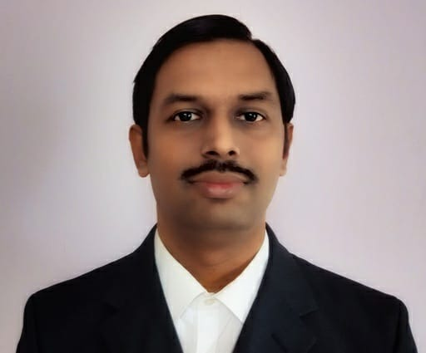
About the Speaker/Chief Guest

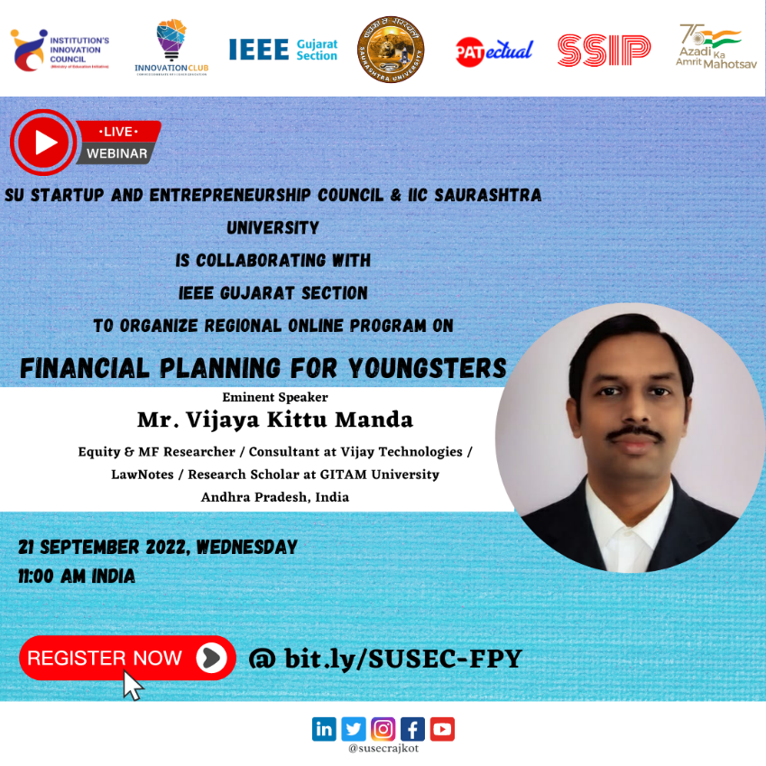

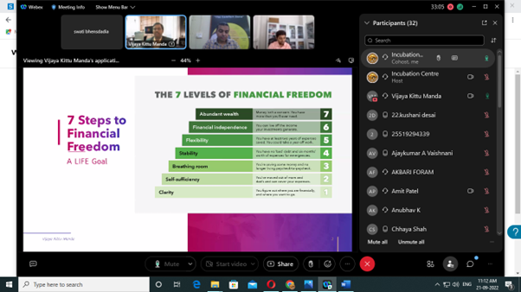
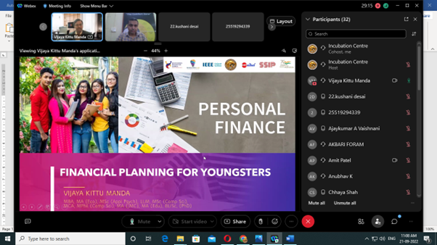

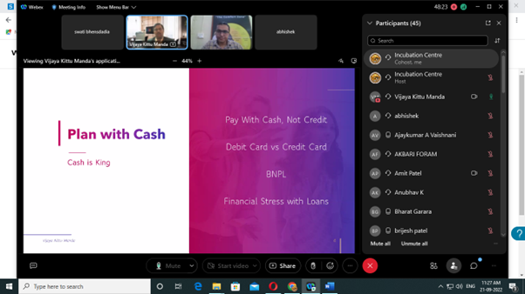
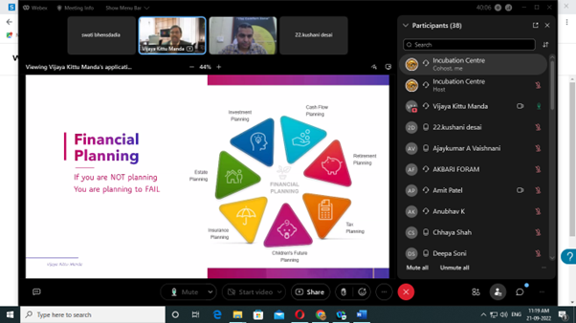

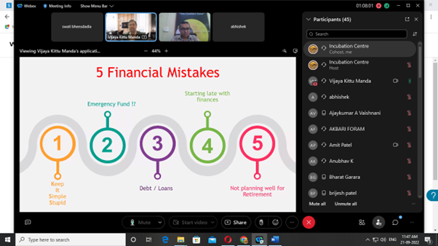
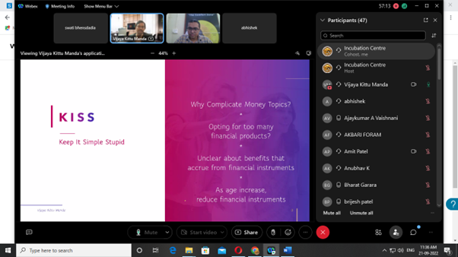

Connect Us:

https://www.linkedin.com/company/susec iic@sauuni.ac.in
https://www.facebook.com/iicsauuni bit.ly/SU-SSIP Location
https://www.instagram.com/susecrajkot https://bit.ly/SUSEC-youtube

